Linking Google Scholar to Torrens Library
Google scholar is a great way to find scholarly information for your research and assessments. Scholar provides results from many sources including: articles, theses, books, abstracts and court opinions, from academic publishers, professional societies, online repositories, universities and other web sites.
You can find Google Scholar at: https://scholar.google.com.au/

Linking Google Scholar to Torrens Library
By linking your Google Scholar search to the Torrens library, you will be provided with the option to “access via my library” where Torrens library provides access to particular books or journal articles.
To do this:
- select the menu symbol at the top left hand side of the screen;
- select the settings cog

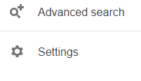
- Select ”library links” and then type in the search bar “Torrens University”(You can see that Google Scholar automatically links to the Libraries Australia database) 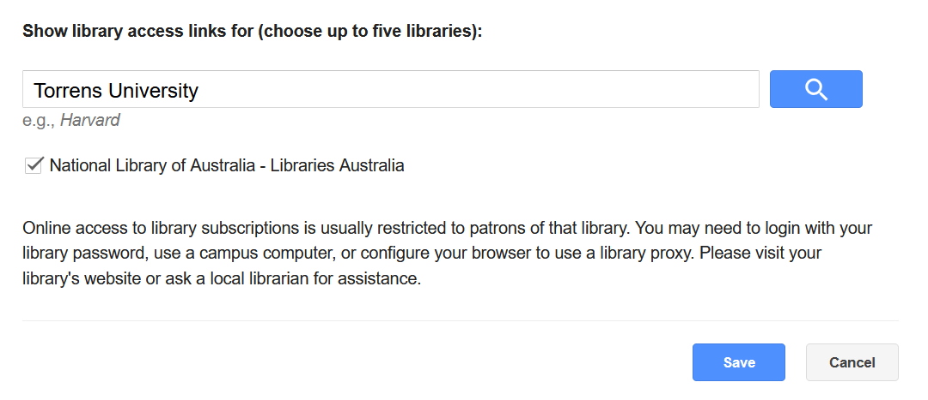
- When Torrens University appears, make sure you tick the box and then save changes.

